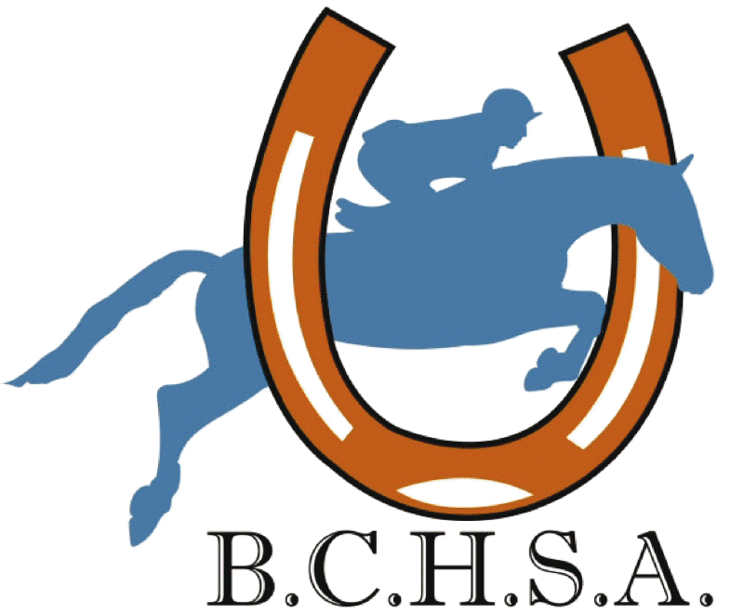
Baltimore County Horse Show Association
Show Fee Report

BCHSA Competition Management/Secretaries:
Please complete the form and return it along with a check for fees collected per the below BCHSA classes. The information included on this form will assist this office to properly credit your account.

Competition Name:________________________________________________________

Competition Date:_________________________________________________________

Competition Location:______________________________________________________

Contact for Show:__________________________________________________________

Phone:_______________________________ Email:______________________________

BCHSA Adult Medal ....................................................... __________ X $5 = ____________
BCHSA Junior Horse Medal ............................................ __________ X $5 = ____________
BCHSA Junior Pony Medal ............................................. __________ X $5 = ____________
BCHSA Pre-Childrens/Adult Medal .................................__________ X $5 = ____________
BCHSA Short Stirrup Eq (WTC)……. .................................__________ X $5 = ____________
BCHSA Long Stirrup Eq (WC)………. .................................__________ X $5 = ____________
BCHSA Scholarship Hack ................................................. __________X $____ (Class Fee) = ________
(Class fee for Hack is a minimum of $10, or as much as a regular class)
Total Amount Enclosed $____________
Please send to:
BCHSA
PO Box 103
Hampstead MD 21074

